**Mini Project – 2 – Trend Store**

Pushed App code to git repo

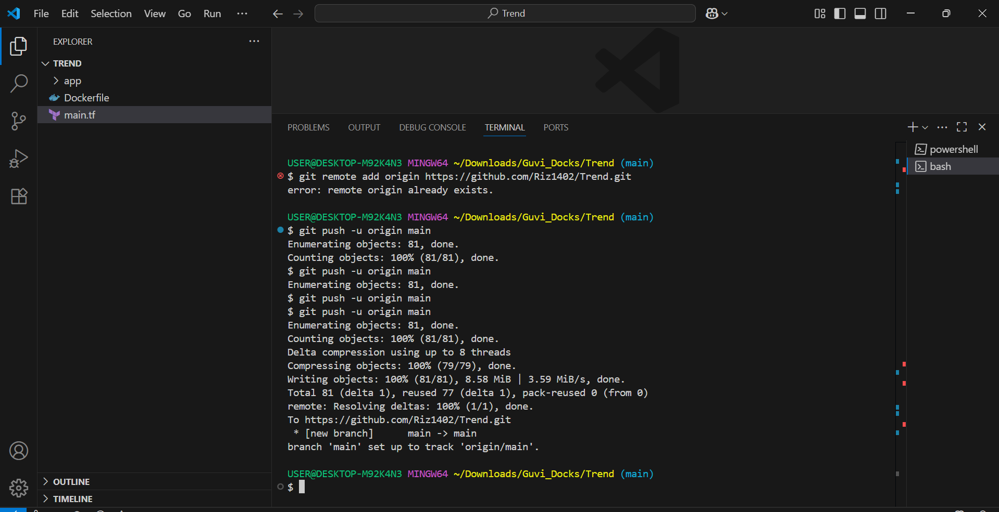

Docker hub repository created

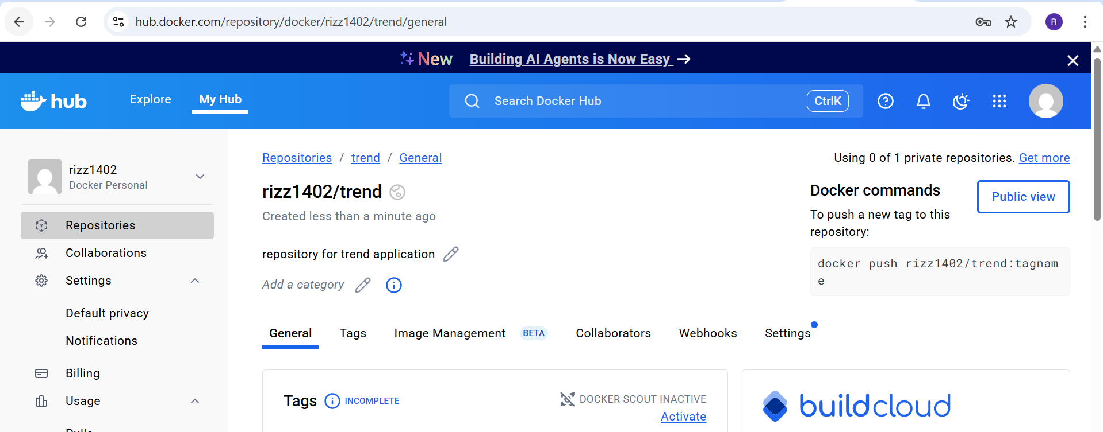

Created VPC, Subnet, IG, Route tables, IAM Roles, EC2 instance using Terraform (main.tf file added in git repo)

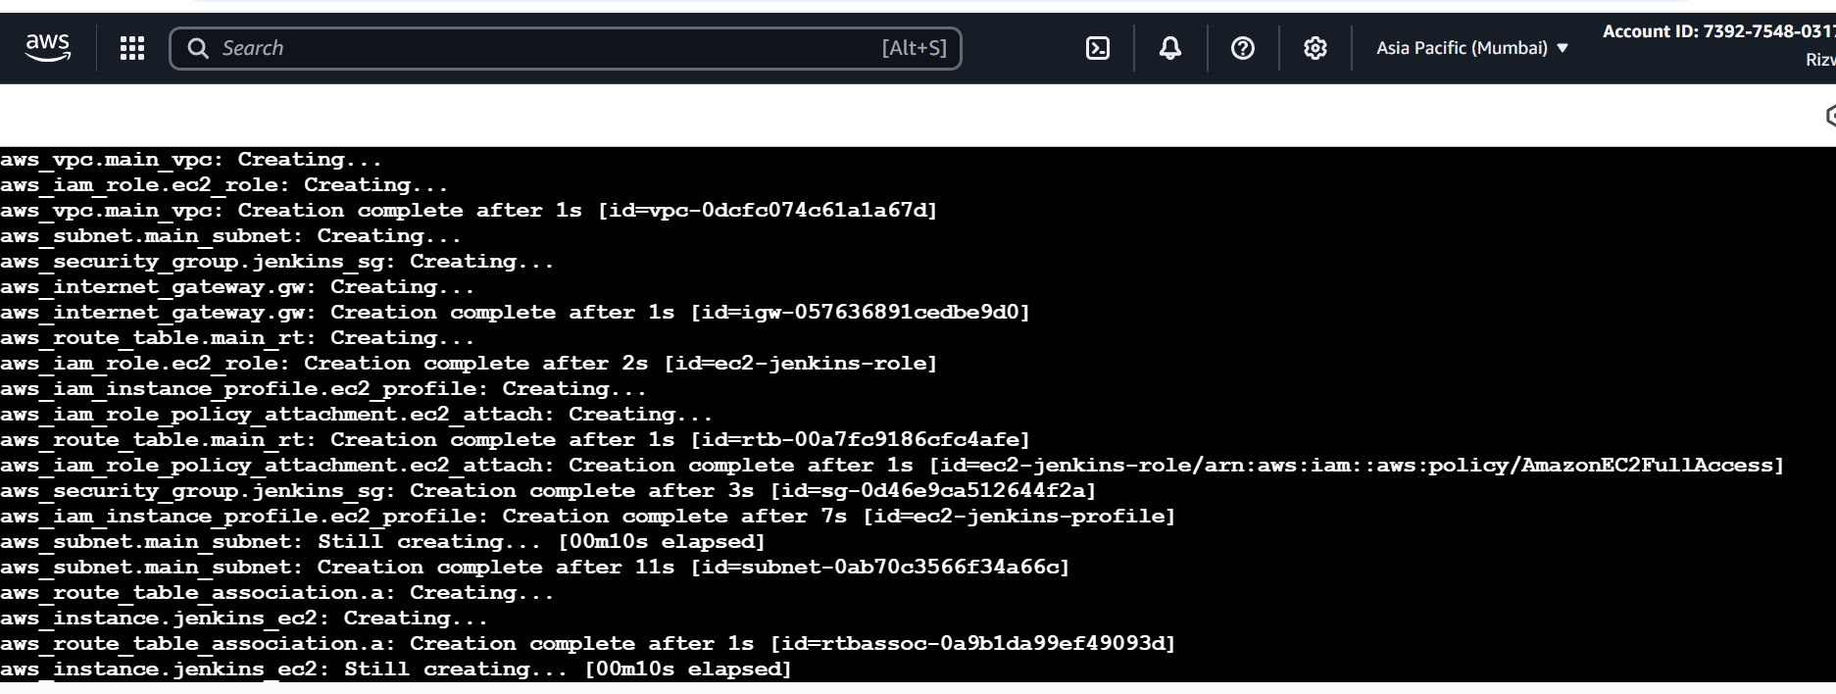

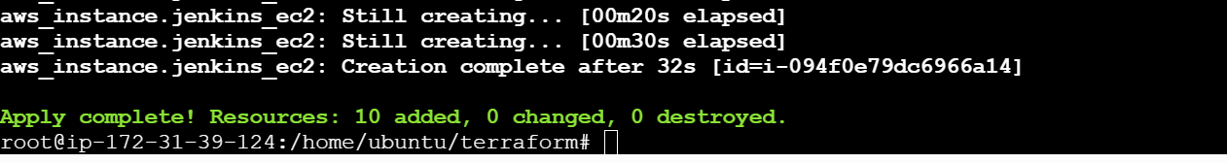

Created Dockerfile, Jenkinsfile, .gitignore, .dockerignore, deployment.yaml and pushed them to Git repository

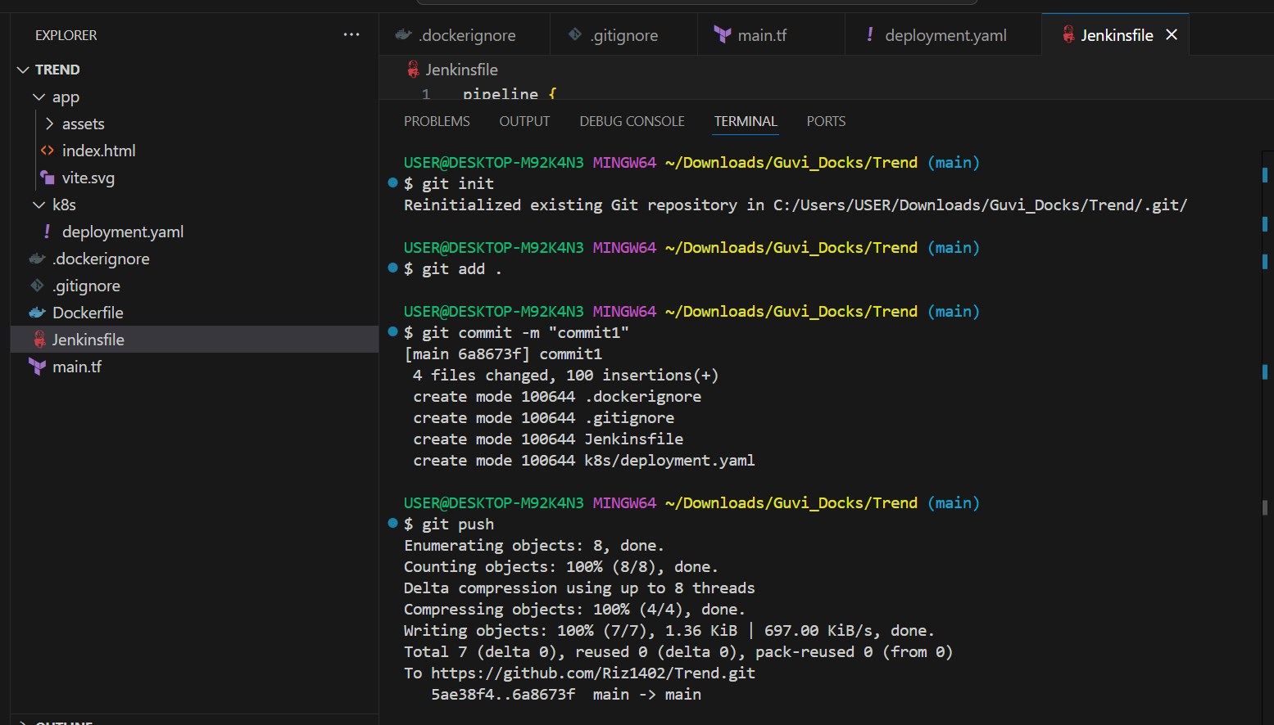

Created EKS cluster with one node

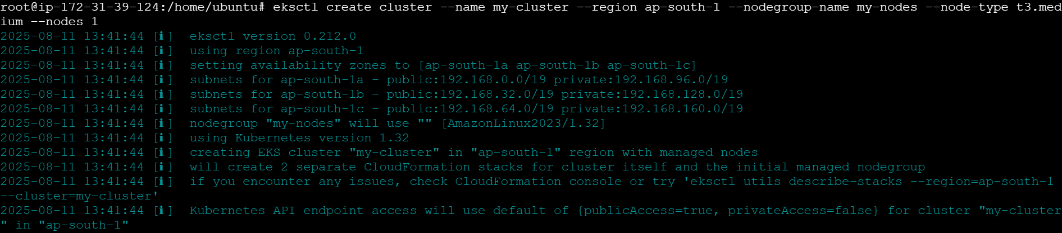

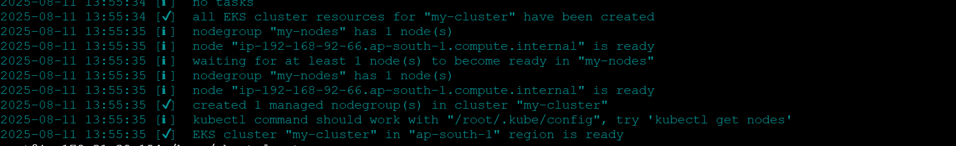

Git repository  
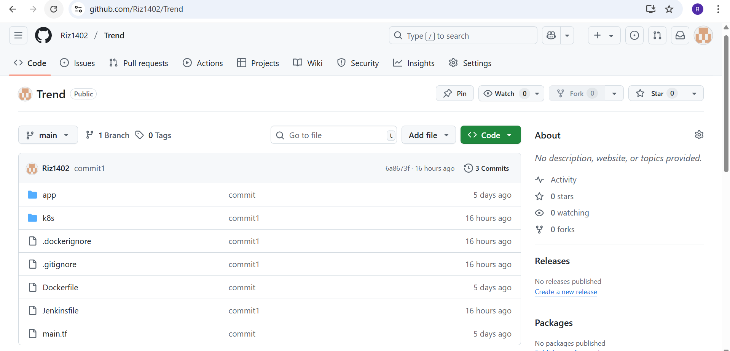

Successful Jenkins pipeline Build

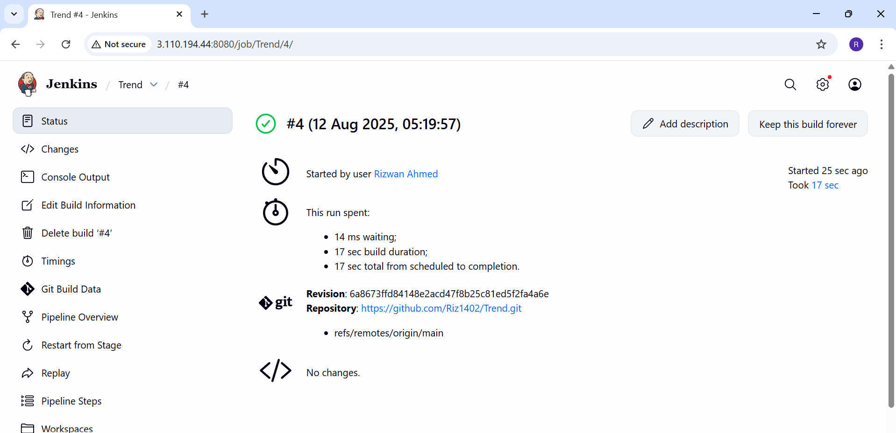

Pushed image to docker hub

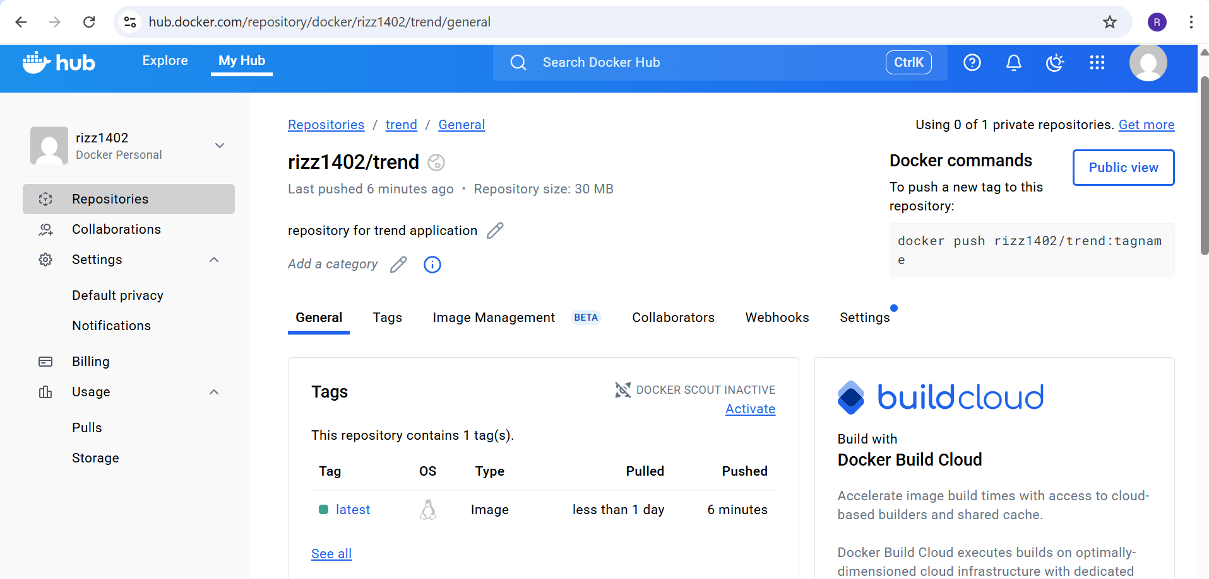

EKS Pods, Deployment and Services

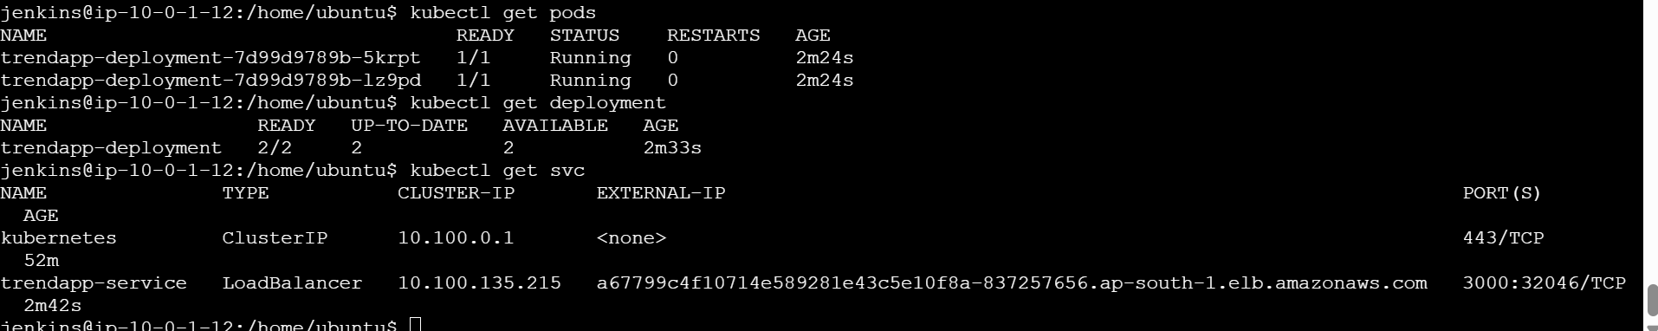

LB - [a67799c4f10714e589281e43c5e10f8a-837257656.ap-south-1.elb.amazonaws.com:3000](app)

App Screen

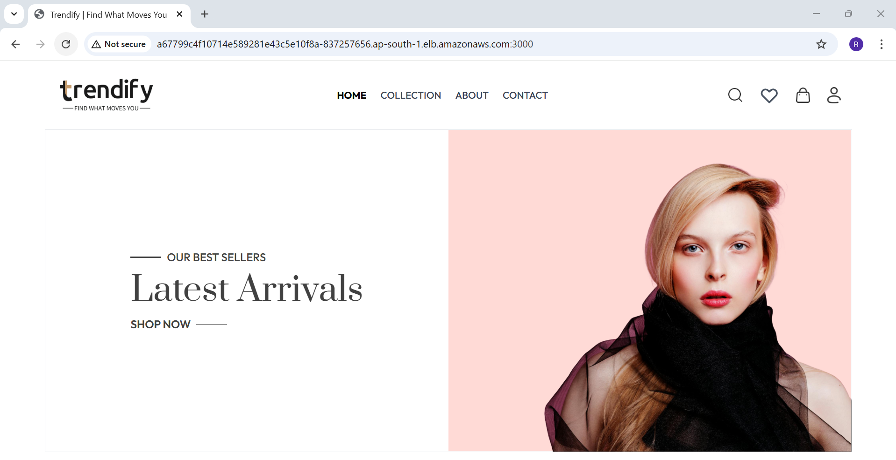

Installed Prometheus and Grafana for monitoring of cluster

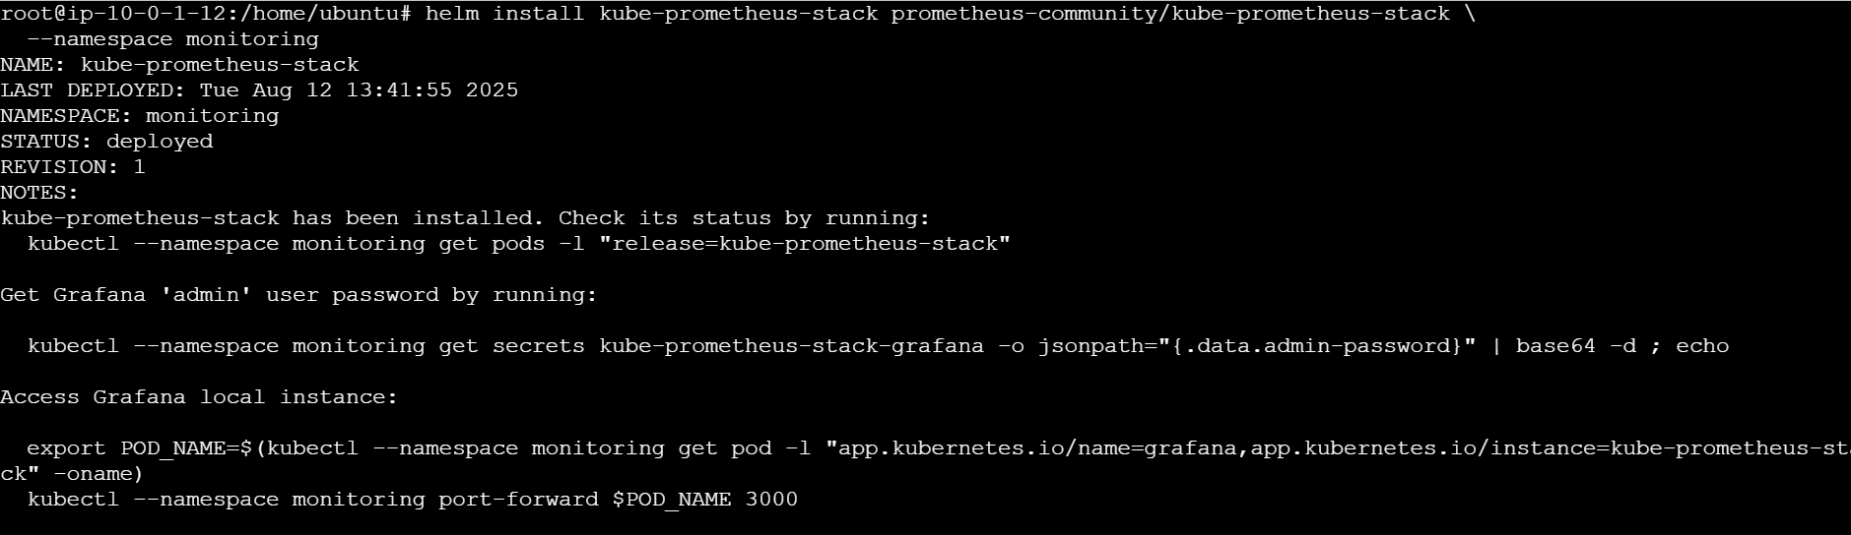

Prometheus and Grafana Pods, deployments and services in monitoring namespace

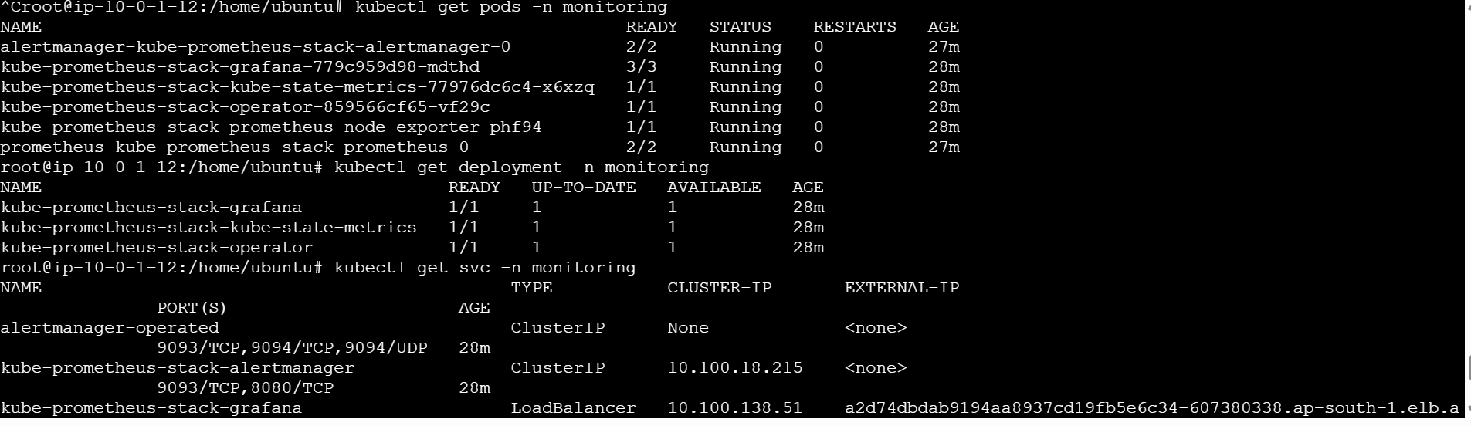

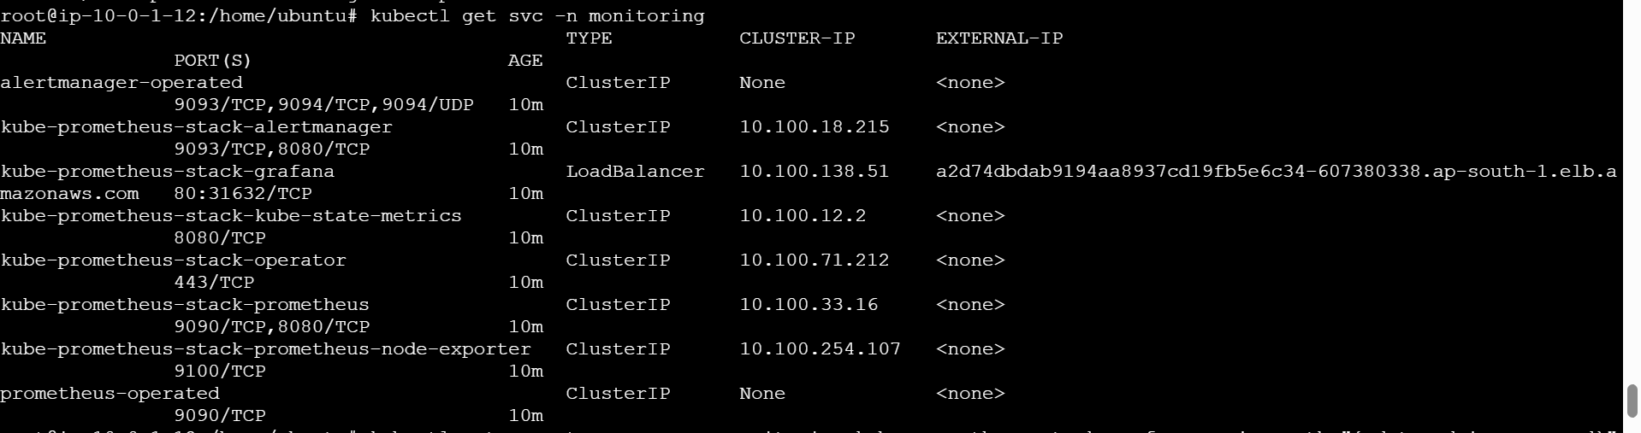

Imported dashboards in Grafana for monitoring.

